Using Koolmoves with Coolpage

Coolpage is a simple, easy to use, yet very powerful “WYSIWYG” web page editor and compiler. Although some Koolmoves users get to grips with Coolpage from the outset, others seem to have problems which are in no way the fault of either Koolmoves nor Coolpage. It is a simple matter to follow a few basic rules and you will find that both programmes will work together in a seamless and and extremely fast manner.

1. Embedding your .SWF

a) Save your Koolmoves project in a specific folder, for example, c:\myproject, and use that project folder for every transaction you make for that particular project in Koolmoves and in Coolpage. This is very important because Coolpage runs it’s preview system from a “Temp” file and for this reason you are unable to preview SWF files using the Coolpage preview button.

b) Export your animation from KoolMoves using File > Export Movie > As SWF (Flash Movie) and HTML Page to the above folder. Do not use File > Export Movie > Add to Existing Web Page.

c) Open with your favourite text editor like NotePad the HTML file that KoolMoves just created and copy the complete contents of the file including headers and body tags.

d) Now go to Coolpage and select “ Insert > HTML object”
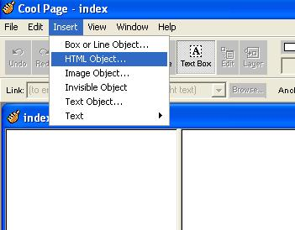

Which will open the following box:

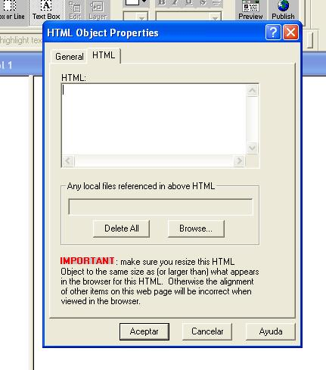

Now paste your code into this box, click “Accept” and your html will appear as a small box inside the main window of your page. This html box should be resized to roughly the same size as your flash movie and positioned to where you want your movie to appear. Remember that the top left corner of the html box is an absolute position and can be used to accurately position your movie.

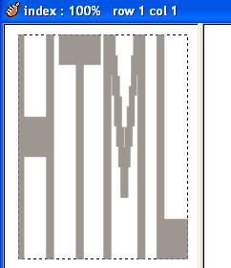

e) Ok, That’s it, you can now save your page in your project folder as a CPG (Coolpage) file and then select “export” to save your page as an HTML file (normally “index.html” which is your main web page file) . You can use the preview function in Coolpage to see the actual position of your movie although the movie will not play. To preview the whole page , (including your movie) go to your project folder and double click on the “index.html” file to open the web page in your favourite browser. If all is to your liking, your page is now ready to be published to your server or hosting service.

2. Some Tips

If you are going to place multiple SWFs on your page, consider making your page a “Frameset”. This can cut down your loading times considerably and also give you much more scope for future edit and page changes.

DO NOT use the “auto publish” features in Coolpage. They are for lazy people and they take away the visibility of a very important part of the process so that if something doesn’t work then it’s possible that the problem is within that part of the process over which you have no control. Get a good FTP “file transfer protocol” programme and use that. ( WS_FTP and CUTE FTP) are highly recommended and are both very easy to use with very good error control.

When you place your SWF HTML code in the Coolpage editor remember to leave the headers and body tags, you can also use them to place some extra meta tags and keywords that will be embedded within the main page body (every little bit helps because search engines in general do not like flash or are not programmed to read flash movies).

Koolmoves and Coolpages are two very powerful user friendly web design tools and when used in conjunction, combine to make a highly professional web design package for the beginner and professional alike.

Enjoy

